Cognitive Engineering: Mac Book Pro

Stephanie Gamino | April 15, 2022

The product I chose is a laptop made by Apple. To be more specific it is the 2020 Mac Book Pro that has the M1 Chip. There are many different features that make this laptop standout from others. Aside from the M1 chip, which is Apples first system on a chip, this specific laptop has a touch bar that is meant to help with shortcuts, two thunderbolt/USB 4 ports, and magic keyboard/ trackpad that has scissor mechanisms. Below is a picture of this laptop.

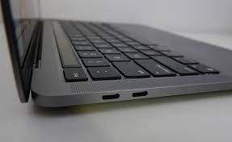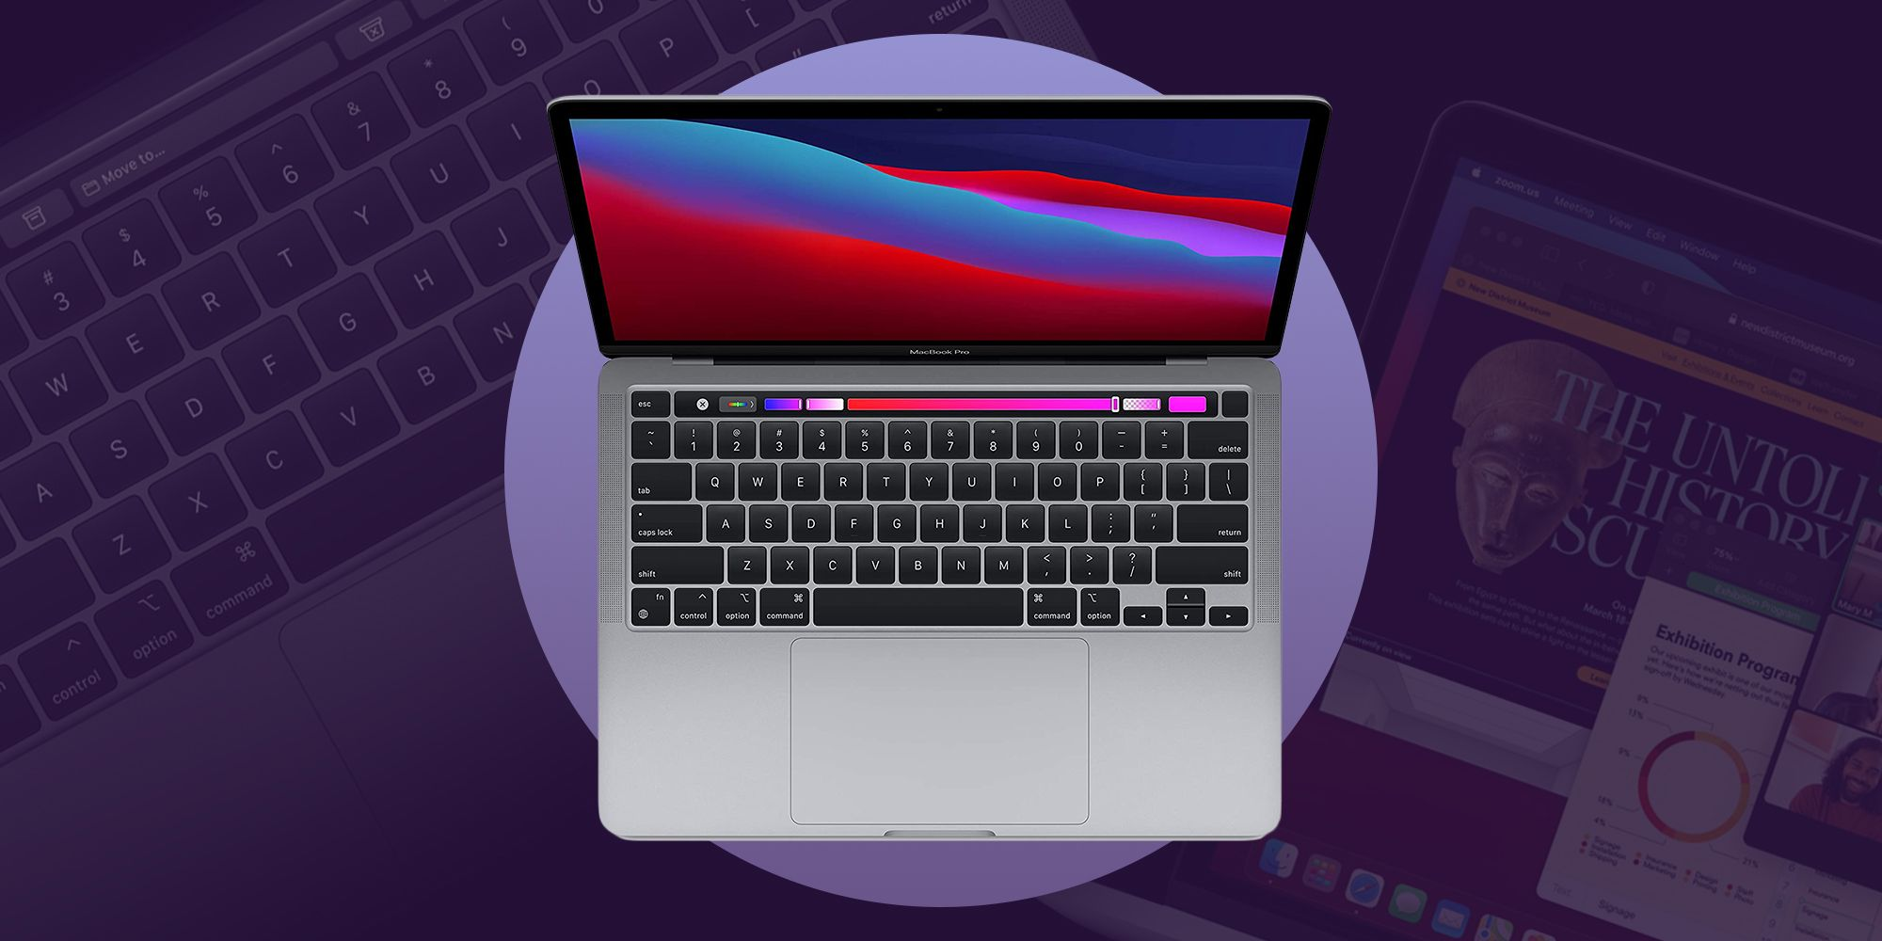

With any technological product, there are varying strengths and weakness. Using Nielsens rule on a matching I think the Mac Book does a good job at simplifying the language. There are very simple and straight forwards words and phrases while using any application. I think matching is something apple does well because it’s not difficult to figure how which application to use and how to locate it, as well as the language inside it. Of course, with any first-time user they might be familiar with the exact words but the language displayed isn’t ambiguous. As for the Nielsens 8th rule of aesthetic and minimal design, I think the Mac Books are aesthetically pleasing. The outer design is very simple but also very sleek. Inside the laptop, there’s the touch bar and the magic keyboard and trackpad. I think the touch bar doesn’t follow the minimalist design. I personally think it’s unnecessary. Like yea it’s pretty cool, but I think it’s inefficient. It might be more practical to have actual keys that a singular strip of the touch bar. Previous of models of the Mac Book pro don’t have the touch bar but instead actual keys. Although it is a cool technology, I think it takes away from the usage of those now digital keys. Additionally, on the outside of the laptop, there are a total of 3 inputs ports. Two are the thunderbolt or USB 4 port and the headphone jack. I think this design of the computer is super impractical. To start off, the thunderbolt keys are not very common. Unless someone knows a lot about Apple and their newer products, it would be very hard to the user to know what that port is and how it works. This connects back to the second rule of heuristics and how it doesn’t match single language. In previous models or other computers, it is very common to have a USB port. For this laptop, one would have to buy an adaptor in order to connect a USB connection to the computer. Although it may be a simple fix, it might just be easier to just provide the port itself. The last port on this computer is the headphone jack. I think this has both strengthens and weaknesses. For instance, many companies such as Apple are moving towards wireless products which include headphones. Although apple does still sell wired headphones, it more common to see Bluetooth headphones. With that, it can make the headphone jack a little impractical but at the same time there are still those who use it. One thing I know I personally like about this laptop is its visibility of system status or heuristic number one. The Mac does a good job on telling users know when its time to update the computer, when the battery is dying, receiving texts or calls, among other things. If errors occur there are pop ups of to let users know it will take some time for the computer to restore. With that, it doesn’t always pop up what the problem is but it does let users know there is a stall happening. Overall, I think this computer is great overall. There are some things that I personally wish were a little different to fit my everyday needs but as a whole, it is very UX friendly.